INTRODUCTION TO PYTHON
Lab sheet 1

- You are tasked with creating a program that determines whether a given year is a leap year or not. A leap year is a year that is exactly divisible by 4, except for years that are divisible by 100 but not by 400. Write a Python program that takes a year as input and prints whether it is a leap year or not.
Conditions for Leap year
- If a year is divisible by 4 and not divisible by 100, it is a leap year.
- If a year is divisible by 100 and not divisible by 400, it is not a leap year.
- If a year is divisible by 400, it is a leap year.

CODE:
#LEAP YEAR
year = int(input("Enter an year : "))
if (year%4 == 0 and year%100 !=0) or (year%400 ==0):
print("LEAP YEAR IT IS !!!!")
else :
print("NOT LEAP YEAR")

OUTPUT:
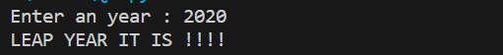

- You are responsible for grading the final exam of a computer science class. The grading scale is as follows:
A: 90-100
B: 80-89
C: 70-79
D: 60-69
F: Below 60
Write a Python program that takes a student's exam score as input and determines their grade using an if-else ladder. The program should display the grade earned by the student.
CODE:
#GRADING
marks = float(input("Enter your computer science marks : "))
if marks>100 :
print ("Invalid Marks")
elif marks >=90 :
print("A grade")
elif marks >=80 :
print("B grade")
elif marks >=70 :
print("C grade")
elif marks >=60 :
print("D grade")
else:
print("F grade")

OUTPUT:
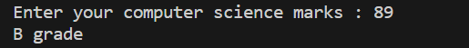

- You are building a program to calculate the cost of shipping a package. The cost depends on the weight of the package and the distance it needs to be shipped. Here are the rules:
• If the package weighs less than or equal to 2 pounds, the base cost is $5.00.
• If the package weighs more than 2 pounds but less than or equal to 10 pounds, the base cost is $10.00.
• If the package weighs more than 10 pounds, the base cost is $20.00.
• If the distance is less than or equal to 100 miles, there's no additional charge.
• If the distance is greater than 100 miles but less than or equal to 500 miles, there's a $5.00 additional charge.
• If the distance is greater than 500 miles, there's a $10.00 additional charge.
CODE:
#shipping
cost = 0

weight = float(input("Enter the weight of your package : "))
distance = float(input("Enter the distance the package need to travel : "))

if weight > 10:
cost+=20
elif weight > 2:
cost+=10
else:
cost += 5

if distance > 500:
cost+=10
elif distance > 100:
cost+=5
print("Total cost : ", cost)

OUTPUT:
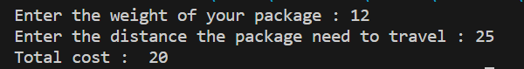

- Accepting user input. Write your observations of the output of (a) to (d)
(a)

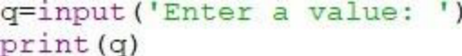

OBSERVATION AND OUTPUT:

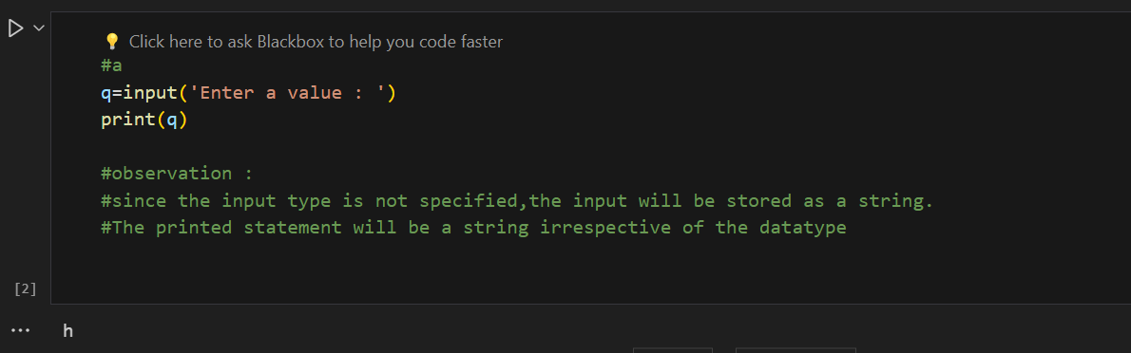

(b)

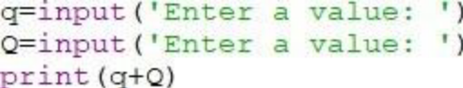

OBSERVATION AND OUTPUT:

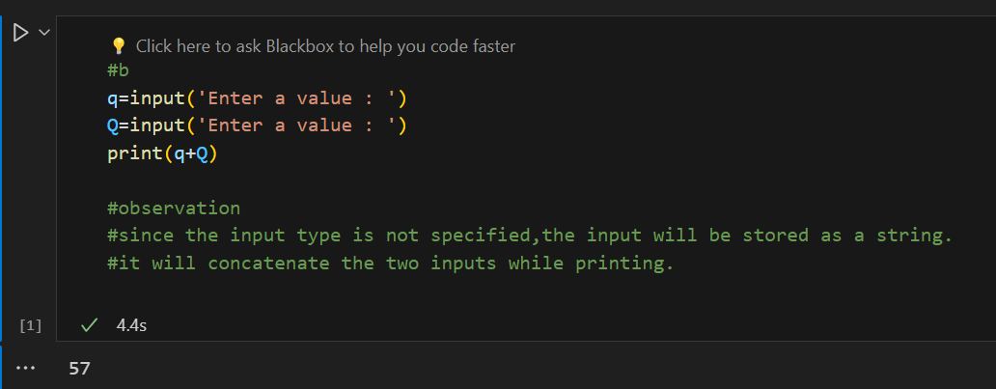

(c)

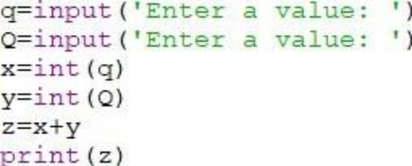

OBSERVATION AND OUTPUT:
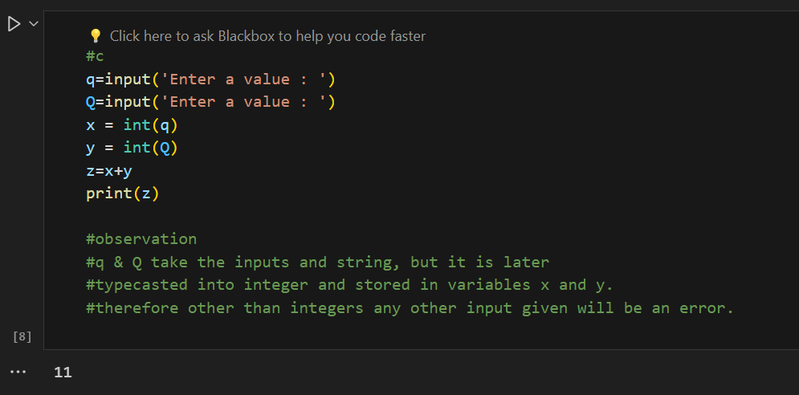

(d)

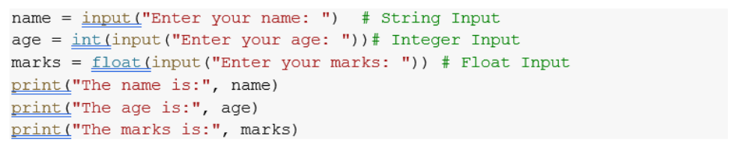

OBSERVATION AND OUTPUT:

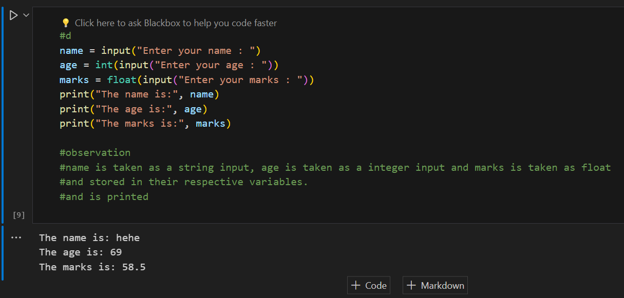

- Write a program to read the number of seconds and print it in the form
hr:min:sec.

CODE:
#Write a program to read the number of seconds and print it in the form hr:min:sec.

seconds = int(input("Enter total seconds :"))

minute = seconds // 60
seconds -= minute*60
hour = minute // 60
minute -= hour*60

print(hour,":",minute,":",seconds)

OUTPUT:
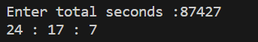

- Which out of the code snippets below, print the numbers from 1 to 10. Give the reason for the error in the code snippets below which does not print from 1 to 10.

(a)

i=1
while i<10:
print(i)
i=i+1
(b)
i=1
while i<=10:
print(i)
i=i+1
(c)
i=3
while i<=10:
print(i)
i=i+2
(d)
i=1
while i<=10:
print(i)
i=i+1
(e)
i=1
while i>=10:
print(i)
i=i+1
(f)
i=1
while i>=10:
print(i)

OBSERVATION :
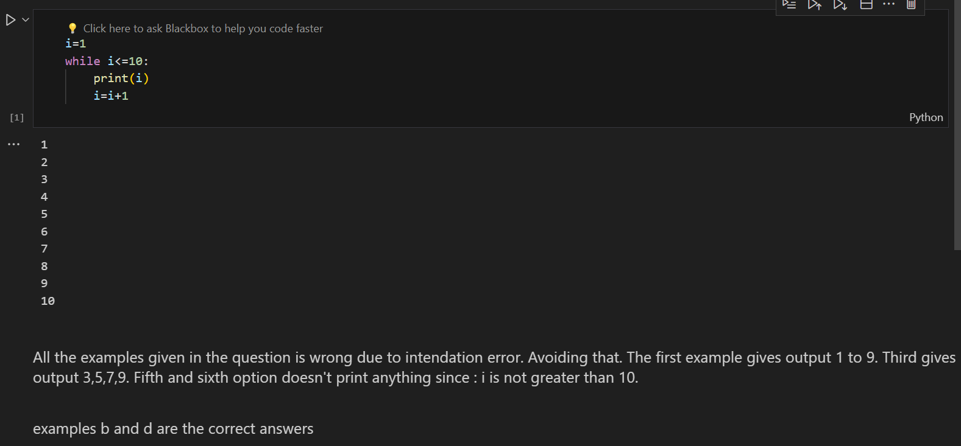

- Write a Python program that prints all the numbers from 0 to 100 except multiples of 3 or 5.
[Hint: Use continue statement.]
CODE:
#Python program that prints all the numbers from 0 to 100 except multiples of 3 or 5.

i = 0
while i<=100:
if (i%3==0 or i%5==0):
i+=1
continue
print(i)
i+=1

OUTPUT:
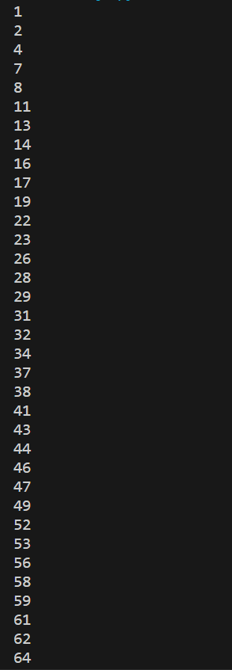

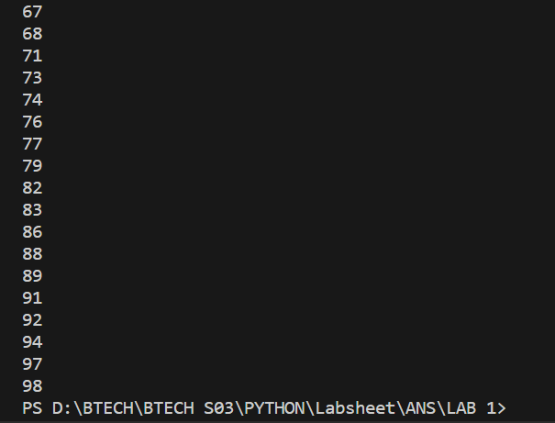

- Write a Python program to take an n-digit integer and print the digits of the number from left to right and right to left.

CODE:
#Python program to take an n-digit integer and print the digits of the number from left to right and right to left.

number = input("Enter a number : ")

print("From right to left :", number[::-1])
print("from left to right :", number)

OUTPUT:
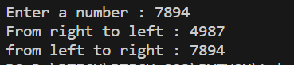

- Write a python program to check if a number given by the user is a palindrome. (Hint: A number is a palindrome if the number is equal to its reverse.)

CODE:
#python program to check if a number given by the user is a palindrome.

n = input("Enter number :")

if n[::-1] == n:
print("palindrome")
else:
print("not palindrome")

OUTPUT:
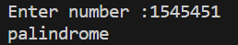

- Write a Python program to find the sum of the below series provided n is a number given by the user.
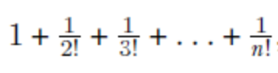
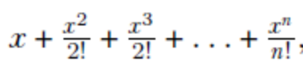

CODE:
from math import factorial

n = int(input("Enter a number : "))
x = int(input("Enter a value x : "))

#sequence 1
sum = 1
for i in range(2,n+1):
sum += 1/factorial(i)
print("sum of sequence 1 :", sum)

#sequence 2
sum2 = x
for i in range(2,n+1):
sum2 += (x**i)/(factorial(i))
print("sum of sequence 2 :", sum2)

OUTPUT:
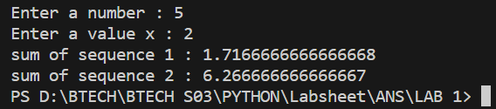

- Write a program to check whether a number is strong number or not.Strong number is a special number whose sum of factorial of digits is equal to the original number. For example: 145 is strong number. Since, 1! + 4! + 5! = 145

CODE:
#strong number
from math import factorial

num = int(input("Enter a number: "))
sum = 0

for i in str(num):
digit = int(i)
sum += factorial(digit)

if sum == num:
print("Strong number")
else:
print("Not a strong number")

OUTPUT:
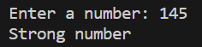

- Write python program to print the below patterns. Take as input no: of rows

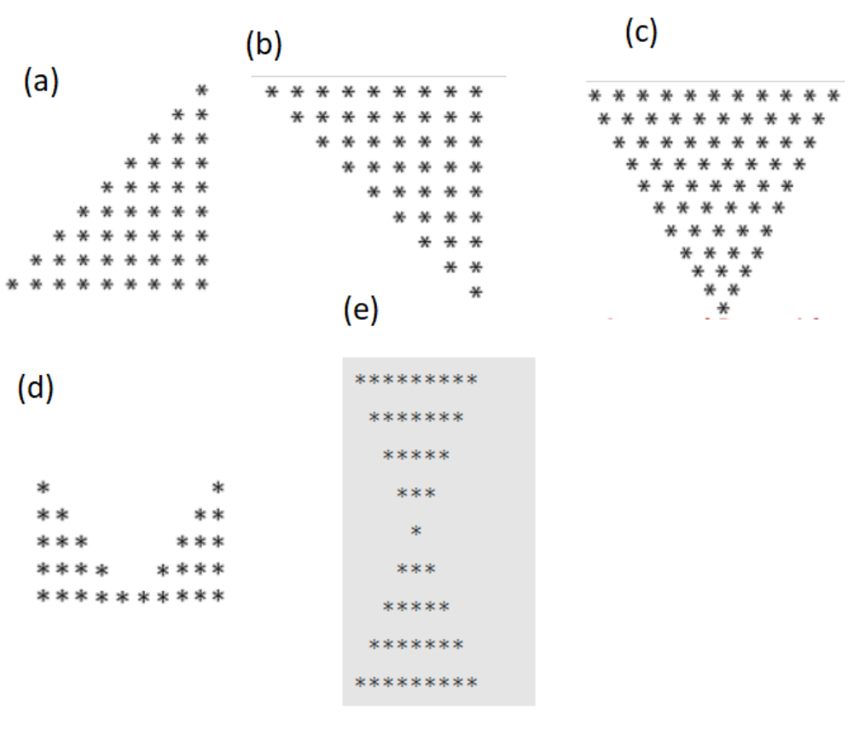

CODE:
n = int(input("Enter a number : "))

print("pattern 1 :")
for i in range(n):
print(' '*(n-i-1)+'*'*(i+1))

print("\npattern 2 : ")
for i in range(n):
print(' '*(i)+'*'*(n-i))

print("\npattern 3 :")
for i in range(n):
print(' '*(i)+'* '*(n-i))

print("\npattern 4 :")
for i in range(n):
print('*'*(i+1)+ ' '*(n-i-1)*2 + '*'*(i+1))

print("\npattern 5 :")
for i in range(n):
print(' '*(i)+'* '*(n-i))
for i in range(2,n+1):
print(' '*(n-i)+'* '*(i))

OUTPUT:

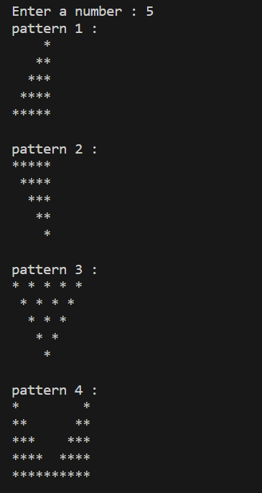
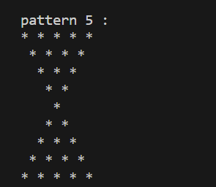

- Write a Python program to print the below patterns.

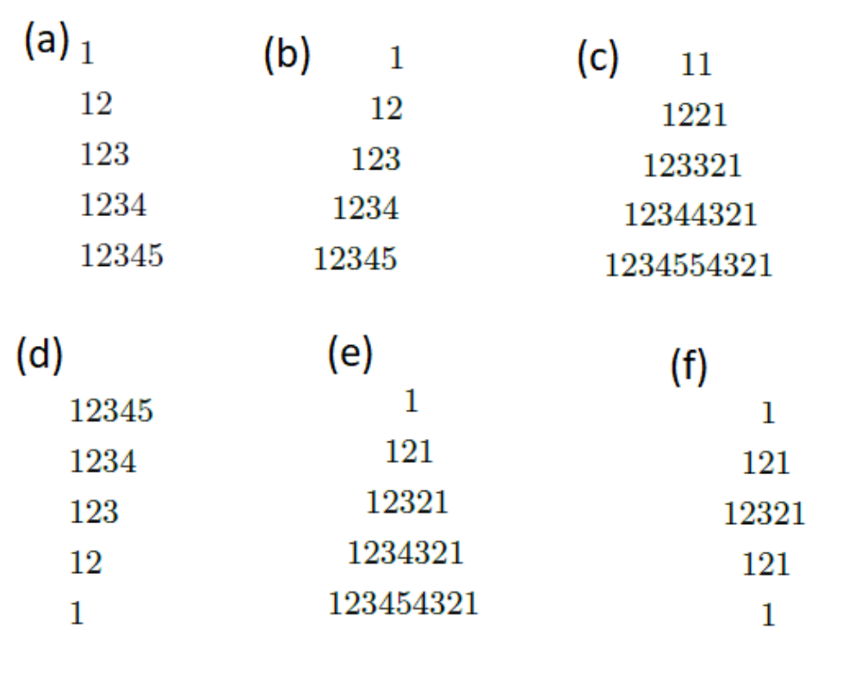

CODE:
n = int(input("Enter a number :"))

#pattern1
print("pattern 1 :")
for i in range(1, n + 1):
for j in range(1, i + 1):
print(j, end="")
print()

#pattern 2:
print("\npattern 2")
for i in range(1, n + 1):
for _ in range(n - i):
print(" ", end='')

for j in range(1, i + 1):
print(j, end='')
print()

#pattern 3:
print("\npattern 3:")
for i in range(1, n+1):
print(" "*(n-i), end="")
for j in range(1, i+1):
print(j, end="")
for j in range(i, 0, -1):
print(j, end="")
print("")
#pattern 4:
print("\npattern 4:")
for i in range(n, 0, -1):
for j in range(1, i + 1):
print(j, end='')
print()

#pattern 5:
print("\npattern 5:")
for i in range(1, n + 1):
for _ in range(n - i):
print(" ", end='')
for j in range(1, i + 1):
print(j, end='')
for j in range(i - 1, 0, -1):
print(j, end='')

print()

#pattern 6:
print("\npattern 6 :")
for i in range(1, n + 1):
for _ in range(n - i):
print(" ", end='')
for j in range(1, i + 1):
print(j, end='')
for j in range(i - 1, 0, -1):
print(j, end='')

print()

for i in range(n - 1, 0, -1):
for _ in range(n - i):
print(" ", end='')
for j in range(1, i + 1):
print(j, end='')
for j in range(i - 1, 0, -1):
print(j, end='')

print()

OUTPUT:
